**Advanced Computer Networking and Security**

**Name: Kranthi Kumar Puttapaka**

**700#: 700753999**

$$LAB2$$

1.done with folder setup

2.installed lab zip file

3.docker setup is up and running

4.using our own VM as attacker instead of seed-attacker docker machine

5.Host A and Host B are other two machines

6.Created shared folder Volumes to access across the containers

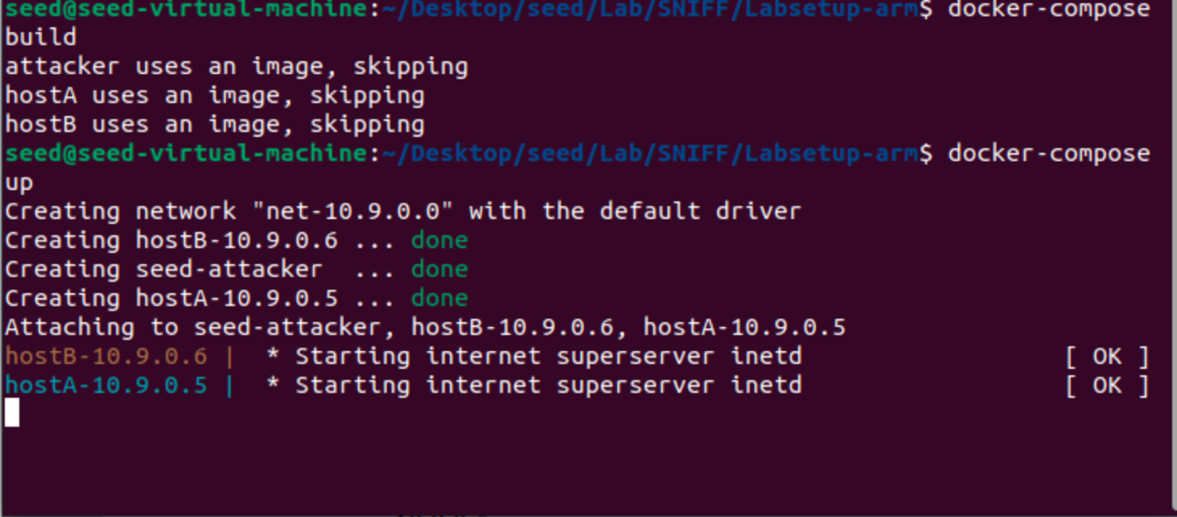

**Task1.1:**

Sniffing the packets

The IP() method generates and returns a new, default, and empty IP packet. When the show() command is executed, it displays the packet's contents. I used 'sudo' to gain root privileges, as they are necessary for packet manipulation

**Task1.1.A:**

Run sniffing using root privileges and without root privileges. Observe the difference

If we run sniffing command without root privileges it throws an error, because raw access to network interface needed root privileges.

**Task1.1.B:**

Sniffing the specific packets using BPF (Berkeley Packet Filtering)

->Capture only ICMP packets

->Capture any TCP packets that comes from a particular IP address and with a destination port 23.

->Capture packets come from or to go to a particular subnet. Pick any update like 128.230.0.0/16 and should not pick the subnet attached to the VM.

**Task1.2:**

Creating ICMP packets and spoofing to destination IP address

Validate ICMP packets through Wireshark

**Task1.3:**

The task here is to find the distance between VM and the selected destination in terms of number of routers in between them using scapy.

**Task1.4:**

**Sniff-and-then-spoofing**

To Implement this we need two machines on the same LAN.

1.VM 2. Docker container

Run sniffing program from VM

Try to ping IP address from docker container

Ping a non-exisitng host on the internet 4.3.2.1

Ping 10.9.0.99 #a non-existing host on the LAN

Ping 8.8.8.8 #existing host on the internet

**IP Route Command to understand the ARP protocol**

**Extra Task 1: Network Sweeper Task**

**Extra Task 2: Multi-Port Scanner**

